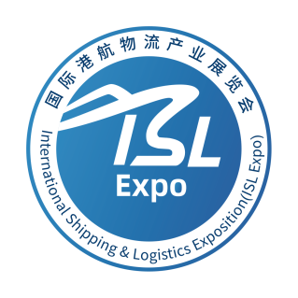

Invitation Letter

2023 International Shipping&Logistics Exposition (Shanghai)
2023 International Shipping&Logistics Exposition (hereafter referred to as “ISL Expo 2023”) is scheduled to be held at Shanghai Convention&Exhibition Center of International Sourcing from November 21 to 23, 2023. ISL Expo 2023, approved by Shanghai Municipal Commission of Commerce, is co-hosted by China Shipping Gazette, Shipping&Logistics Branch of China Communications and Transportation Association, and Shanghai Shipping 50-Key-Stakeholder Development and Research Center, co-sponsored by China Association of Port-of-Entry and Automatic Identification Manufacture Association of China, co-organized by Shanghai International Freight Forwarders Association and Shenzhen Cross-border E-Commerce Association, supported by China Shippers’ Association, China Maritime Pilots’ Association, Shanghai Hongkou District Investment Promotion Office (Shipping Industry Office).
This exposition is to be held on the occasion of the 10th anniversary of the joint construction of the "Belt and Road" initiative. It is an authoritative exhibition that links the upstream and downstream resources of the shipping&logistics industrial chain such as trade cargo owners, ports, airlines, railways, and freight forwarding and logistics as well as serves the high-quality development of international trade. The total area for exhibition is 13,000 square meters, including six major exhibition areas: "Port Enterprise Exhibition Area", "Shipping Enterprise Exhibition Area", "Freight Forwarding Logistics Exhibition Area", "Port and Shipping Digital Exhibition Area", "Railway Freight Forwarding Exhibition Area" and "Air Freight Forwarding Exhibition Area". “Freight Forwarding Logistics Exhibition Area" is further subdivided into LCL(Less than Container Load), cold chain, heavy cargo, hazardous chemicals, storage yards, trailers, customs clearance, overseas warehouses and cross-border e-commerce logistics, comprehensive freight forwarding logistics and other sectors. It is expected that over 20,000 professional visitors, including 2,000 representatives of shippers or consignors, will visit and participate in the exposition.
On the occasion of the 30th anniversary of the founding of China Shipping Gazette and the 10th anniversary of the founding of the China Shipping 50-Key-Stakeholder Forum, the exposition will grandly hold almost 100 special conferences and honorary awarding ceremonies, such as "Salute for 30 Years" - the 30th Anniversary of the Founding of China Shipping Gazette, the 10th Annual Meeting of the China Shipping 50-Key-Stakeholder Forum, the 2nd Membership Meeting of the Shipping&Logistics Branch of China Communications and Transportation Association, the 6th Global Trade and Container Transportation Conference, the 2nd Annual Meeting of the "Round Table on Digitization of Port and Shipping Logistics", etc.
ISL Expo 2023 will be featured by "Gathering Ports, Shipping, Airlines, and Railways to Link International Trade Shippers", highlighting authority, professionalism, foresight, and pragmatism, creating an industry event of different scale and with remarkable effects and outstanding achievements. This exposition is designed to provide a business-oriented platform for all stakeholders in the logistics chain and encourage interactive and lively exchanges on transport solutions and business opportunities.
We are hereby sincerely inviting your company to schedule exhibition booths and participate in the conference activities.for business opportunities and efficient collaboration.

Contact Person: Michelle Chen
TEL.:+86 13671699403
Email:ctyhb@163.com
Add: Room 504, North Bund Shipping Center No.315 Emei Road , Hongkou District,Shanghai

China Shipping Gazette

Shipping&Logistics Branch of China Communications and Transportation Association

Shanghai Shipping 50-Key-Stakeholder Development Research Center

Exhibition Overview
1.Organization Structure
International Shipping&Logistics Exposition 2023（ISL Expo 2023）
Approved by:
Shanghai Municipal Commission of Commerce
Directed by:
China Communications and Transportation Association
Hosted by:
China Shipping Gazette, Shipping&Logistics Branch of China Communications and Transportation Association, Shanghai Shipping 50-Key-Stakeholder Development and Research Center
Sponsored by:
China Association of Port-of-Entry, Automatic Identification Manufacture Association of China.
Co-organized by:
Shanghai International Freight Forwarders Association, Shenzhen Cross-border E-Commerce Association.
Supported by:
China Shippers’ Association, China Maritime Pilots’ Association, Shanghai Hongkou District Investment Promotion Office (Shipping Industry Office).

2.Highlights of the Exhibition
❖ 2000+ Representatives of shippers and consignors enterprises invited to attend the exhibition, mainly from manufacturing, international trade, cross-border e-commerce and other fields
❖ 20000+ Logistics industry representatives to interact on site
❖50+ Domestic port and shipping logistics and shippers and consignors enterprises
❖ 20+ Overseas logistics association participating
❖ 6 Major professional exhibition areas
❖ 5 Themed forums + over 100 business connecting conferences
❖ 200+ Public media and we-media are invited to participate
❖ Official WeChat account of China Shipping Gazette with 200,000+ professional readers' followers, providing exhibitors with value-added communication services before, during and after the Exposition.
Time: November 21 to 23, 2023
Address: Shanghai Convention & Exhibition Center of International Sourcing
(No.2739 Guangfu West Road, Putuo District, Shanghai)

- Price
Booth Type | Price | Installation Services
Standard Booth | USD 250/M² | Free (No Painting and Customized Decorations )
Luxury Standard Booth | USD 275/M² | Free (No Painting and Customized Decorations )
Raw Space Booth | USD 220/M² | The exhibitor will entrust the builder and bear the costs.
Preferential Policies:
1.Raw space booth renting from 30 square meters.
2.Exclusive Discounts: 10% off for members of Shipping& Logistics Branch; 20% off for members of the Board of Directors of China Shipping Gazette.
3.Luxury Standard Booth: better location and free advertising display space on its standard booth lintel board.

- Basic Information of Exhibition
A total area of 13,000 square meters, including "Port Enterprise Exhibition Area", "Shipping Enterprise Exhibition Area", "Freight Forwarding Logistics Exhibition Area", "Port and Shipping Digital Exhibition Area", "Railway Freight forwarding Exhibition Area" and "Air Freight forwarding Exhibition Area".
Audience: over 2,000 representatives of shippers' enterprises, 5,000 guests of the conference and 15,000 professional visitors.

- Scope of Exhibitors
1. Shipping Enterprises: including container, bulk cargo, special transportation, roll on/roll off and other maritime and inland transportation enterprises, as well as carrier enterprises such as railway-water intermodal transport, river-sea intermodal transportation, and NVOCC;

2. Port Enterprises: including port and terminal enterprises such as containers, bulk cargo, special transportation, roll on/roll off, as well as logistics service enterprises relying on port resources;

3. Freight Forwarding Logistics: various types of freight forwarding enterprises; overseas warehouses and cross-border e-commerce logistics enterprises; major items, hazardous chemicals, and cold chain logistics enterprises; warehousing and storage yard enterprises; trailer companies; customs declaration and inspection enterprises, etc;

4. Railway Freight Exhibition Area: railway transport enterprises, railway-water intermodal transport logistics enterprises, cross-border train platform enterprises, etc.;

5. Digitization of Port and Shipping Logistics: smart ports and digital shipping enterprises; digital shipping platform; port and shipping logistics SaaS service providers, etc;

6. Air Cargo Exhibition Area: air cargo transport enterprises, air cargo terminals, air freight forwarding enterprises, etc.;
6. Concurrent Events:
1. The 30th Anniversary Conference of China Shipping Gazette&"Salute to 30 Years" Gala
Guiding Unit: China Communications and Transportation Association
Sponsor: China Shipping Gazette
Organizers: Shanghai Shipping 50-Key-Stakeholder Development Research Center,
Advanced Media
China Shipping Gazette was founded in 1993, and with 30 years’ development, it has always adhered to the forefront of shipping&logistics industry development. During this event, it will invite relevant leaders from the government and associations, port and shipping logistics entrepreneurs, renowned experts and scholars, etc. to gather around and embrace common development. It will also organize and present a series of awards titled "Salute to the Past 30 Years" to commend port and shipping logistics enterprises that have made outstanding contributions to the industry's development over the past 30 years.

2. The 10th Annual Conference of "China Shipping 50-Key-Stakeholder Forum"
Sponsors: Dalian Maritime University, Shanghai Maritime University, China Waterborne Transport Research Institute, Shanghai Shipping Exchange, China Shipping Gazette.
Organizer: Shanghai Shipping 50-Key-Stakeholder Development Research Center, Advanced Media
The "China Shipping 50-Key-Stakeholder Forum" was founded on December 21, 2013, and its members include key leaders and well-known experts from key port and shipping enterprises and institutions in mainland China and Hong Kong, Macao, and Taiwan regions. As a special commemorative event of this year, it will definitely attract more forum members and experts to attend.

3. The 2nd Member Conference of the Shipping& Logistics Branch of China Communications and Transportation Association and Release Dinner of China's Advantageous Freight Forwarding and Shipping Technology Recommended Brands
Guiding Unit: China Communications and Transportation Association
Sponsor: Shipping &Logistics Branch of China Communications and Transportation Association
Organizers: Shanghai Shipping 50-Key-Stakeholder Development Research Center, Advanced Media
Since its first general meeting of the Shipping&Logistics Branch of China Communications and Transportation Association was held in Qingdao in December 2020, a total of over 1200 members have been developed under the leadership of Shanghai International Port Group. The upcoming second general meeting of the members is an important meeting to be held again after three years, which is a visual display of the development achievements of the branch in the past three years. The Secretariat will invite all members to attend the conference. Meanwhile, a release ceremony will be held for the "Recommended Brands for China's Advantageous Freight Forwarders and Shipping Technology".

4. The 6th Global Trade and Container Transport Conference
Sponsors: China Shipowners Association, Shanghai Shipping Exchange, China Shipping Gazette
Organizers: Shanghai Shipping 50-Key-Stakeholder Development Research Center, Advanced Media
The Global Trade and Container Transport Conference is a professional conference on container transport jointly organized by China Shipowners Association and Shanghai Shipping Exchange at the invitation of China Shipping Gazette, which takes the lead in organizing and executing the conference. The conference was established in Shanghai in June 2016 to commemorate the 60th anniversary of the world's global maritime container voyage. After seven years, the conference is once again to be held in Shanghai, and the organizers will extensively invite global container shipowners, ports, freight forwarding and logistics enterprises, trade cargo owners, and experts to attend.

5. The 2nd Annual Conference of "Round Table on Digitization of Port and Shipping Logistics"
Sponsors:
China Shipping Gazette
Ganghang Zongheng (Shanghai) Digital Technology Co., Ltd.
Shenzhen Penghai Electronic Data Interchange Co., Ltd.
Zhejiang Four-Port Linkage Development Co., Ltd.
Yungangtong Affiliated to Qingdao Port International Co., Ltd.
Guangzhou Port Data Technology Co., Ltd.
Tianjin Suixing Technology Co., Ltd
Organizers: Shanghai Shipping 50-Key-Stakeholder Development Research Center, Advanced Media
The initiating units of the "Round Table on Digitization of Port and Shipping Logistics" include six major container port data platform enterprises in China, and member units include digital unicorn enterprises and professional technical service providers in this field. The round table aims to promote upstream and downstream collaboration and cooperation through regular exchanges and discussions among members, and provide assistance for the digital transformation of the port and shipping logistics industry. This annual meeting will be presided over by the rotating executive committee of the round table and the main person-in-charge of Ganghang Zongheng (Shanghai) Digital Technology Co., Ltd., a subsidiary of Shanghai International Port Group.

7. List of Above Activities
Activity Name | Time | Place | Scale
2023 International Shipping&Logistics Exposition | 09:00-16:30 on the 21st  09:00-16:30 on the 22nd  09:00-14:00 on the 23rd | 1st and 2nd floor exhibition hall | 350 exhibitors; an area of 13,000 square meters; 20,000 visitors
Exhibition Opening Ceremony&Launch Ceremony of "Ship and Shipment Integrity Collaborative Initiative" | 09:00-10:30 on the 21st | to be determined | 1,000 people
Exposition Visitation by Leaders and Guests | 10:30-12:00 on the 21st | 1st and 2nd floor exhibition hall | 100 people
The 6th Global Trade and Container Transport Conference | 13:30-17:30 on the 21st  09:00-12:00 on the 22nd | 3rd floor meeting area | 800 people
The 10th Annual Meeting of the "China Shipping 50-Key-Stakeholder Forum" | 14:30-17:30 on the 21st | 3rd floor meeting area | 100 people
Friendship Business Reception | 16:30-18:00 on the 21st | 3rd floor viewing platform | 200 people
The 30th Anniversary Conference of China Shipping Gazette&"Salute to 30 Years" Gala | 18:00-21:00 on the 21st | 3rd floor meeting area | 1000 people
Chairmen's Round table conference for China Logistics Listed Companies | 09:00-11:00 on the 21st | 3rd floor meeting area | 50 people
China Shipping 50-Key- Stakeholder Forum Youth Entrepreneurs Summit | 10：00-12:00 on the 22nd | 3rd floor meeting area | 100 people
The 2nd Member Conference of the Shipping&Logistics Branch of China Communications and Transportation Association | 13:30 to 17:30 on the 22nd | 3rd floor meeting area | 1,000 people
The 2nd Annual Conference of "Round Table on Digitization of Port and Shipping Logistics" | 14:30-17:30 on the 22nd | 3rd floor meeting area | 100 people
The 1st International Supply Chain Logistics Advanced Training Course | 09：00-12：00 on the 22nd  13：30-17：00 on the 22nd | 3rd floor meeting area | 300 people
Cross-border E-commerce Development (Shanghai) Forum | 09：00-12：00 on the 22nd | 3rd floor meeting area | 300 people
China Automobile Export and International Logistics Forum | 09：00-12：00 on the 22nd | 3rd floor meeting area | 200 people
China Construction Machinery Export and International Logistics Forum | 13：30-17：00 on the 22nd | 3rd floor meeting area | 200 people
Release Dinner of China's Advantageous Freight Forwarding and Shipping Technology Recommended Brands | 18：00-20：00 on the 22nd | 3rd floor meeting area | 600 people
China Solar Photovoltaic Products Export and International Logistics Forum | 09:00-12:00 on the 23rd | 3rd floor meeting area | 200 people
Tropical Fruit Import and International Logistics Forum | 13：30-17：00 on the 23rd | 3rd floor meeting area | 200 people
International Trade and Export Lecture | 09:00-12:00 on the 23rd | 3rd floor meeting area | 200 people
Please stay tuned for more updates on scheduled events!

- Exhibition Application Form

Booth Reservation
Standard Booth:
Standard Booth: 1780 yuan/square meter:_____ M²
Luxury Standard Exhibition: 1980 yuan/square meter:_____ M²
Single opening _____, Double opening _____. (Double opening charges 10% extra)
For more than one booth, please specify: connecting opening, non-connecting opening..
Raw Space: 1580 yuan/square meter:_____ M²
If it is necessary to build a two-story booth, the price of the upper booth is 50% of the price of the respective bottom booth.
PAYMENT SHOULD BE MADE TO
Account Name: Beijing Advanced Media Investment Management Co., Ltd.
Bank of Deposit: Sanyuanqiao Sub-branch in Beijing, Bank of China Limited
Account No.: 348059165621
Payment Amount: RMB (In Capital);
RMB (In Words).
Settlement Time: ___________before the completion of payment
Exhibitor ( Effective under Seal):
Date:

through □, not through □.
◆ Space only booth:
1580 yuan/square meter:________ m2
If a second floor booth is required, the price of the upper floor booth is 50% of the price of the respective lower floor booth

Exhibitor Details
Company Name (English):_______________________
Company Name (Chinese):_______________________
Mailing Address:_______________________
Contact Person:_________ Contact No.:______________
Fax:_________ Mobile:______________
E-mail:_______________________________
Company Website:_______________________________
Exhibits:______________
Exhibition Details
If it is consistent with the "Exhibitor Details", it may not be filled in.
Contact Person: Tel.:
Address:
Joint Exhibitor
Each joint exhibitor or agent shall pay an additional RMB 1500 joint exhibition fee.
There are _______ Joint Exhibitors in total.
Additional agencies are not authorized to have agency rights.

- Moments of the Last Exhibition
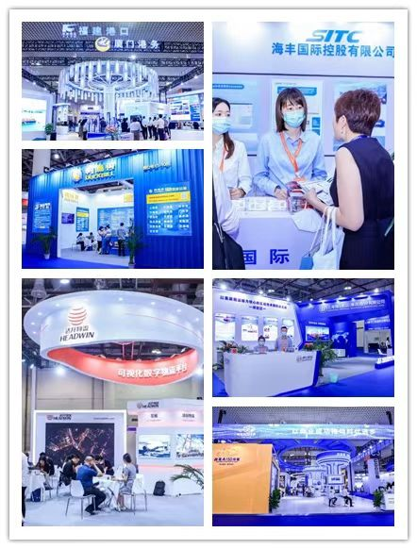
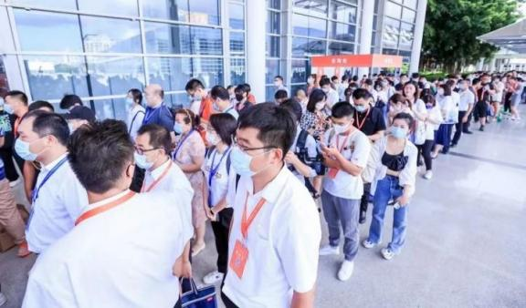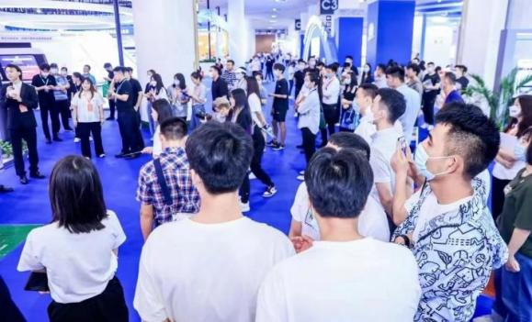
This will be an excellent chance for you to meet more global customers and discuss business with each other!
We sincerely welcome you to come! Please check below for more details:
Exhibition Time: Nov. 21st- 23rd, 2023.
Exhibition Place: Shanghai Convention&Exhibition Center of International Sourcing , Shanghai, China.
Exhibition Area: 13,000 M²
Target Audience: Over 20,000 estimated Chinese and International professional visitors will come to this Expo.
JOIN US NOW.

